
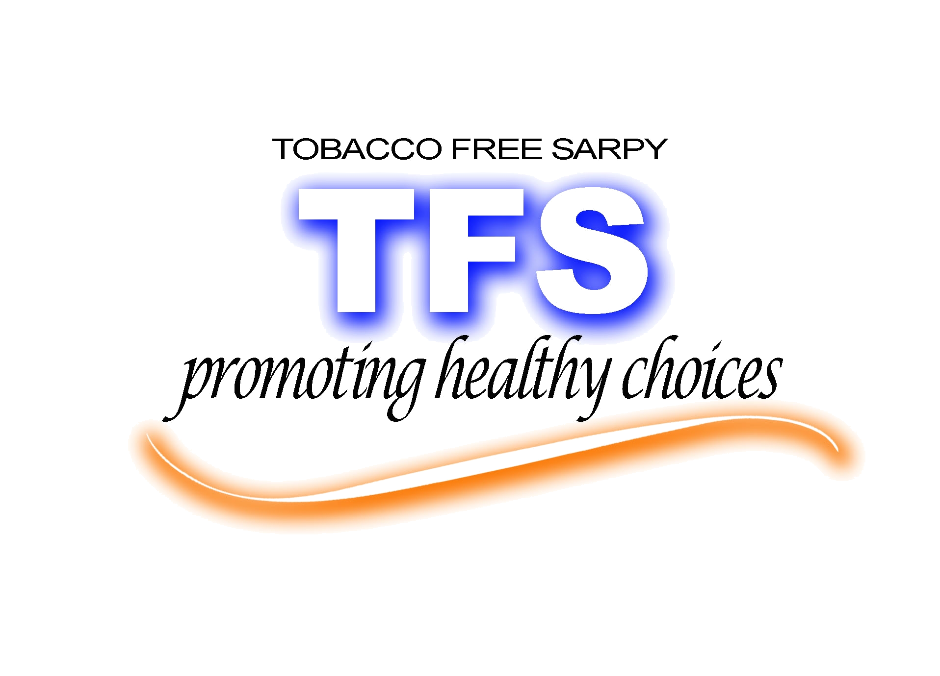

WELCOME TO THE
Tobacco Free Sarpy
Recognition Luncheon

FIRST FLOOR
OGRAM SUITE

Keynote Speaker:
Senator Tim Gay

