Tobacco Free Sarpy
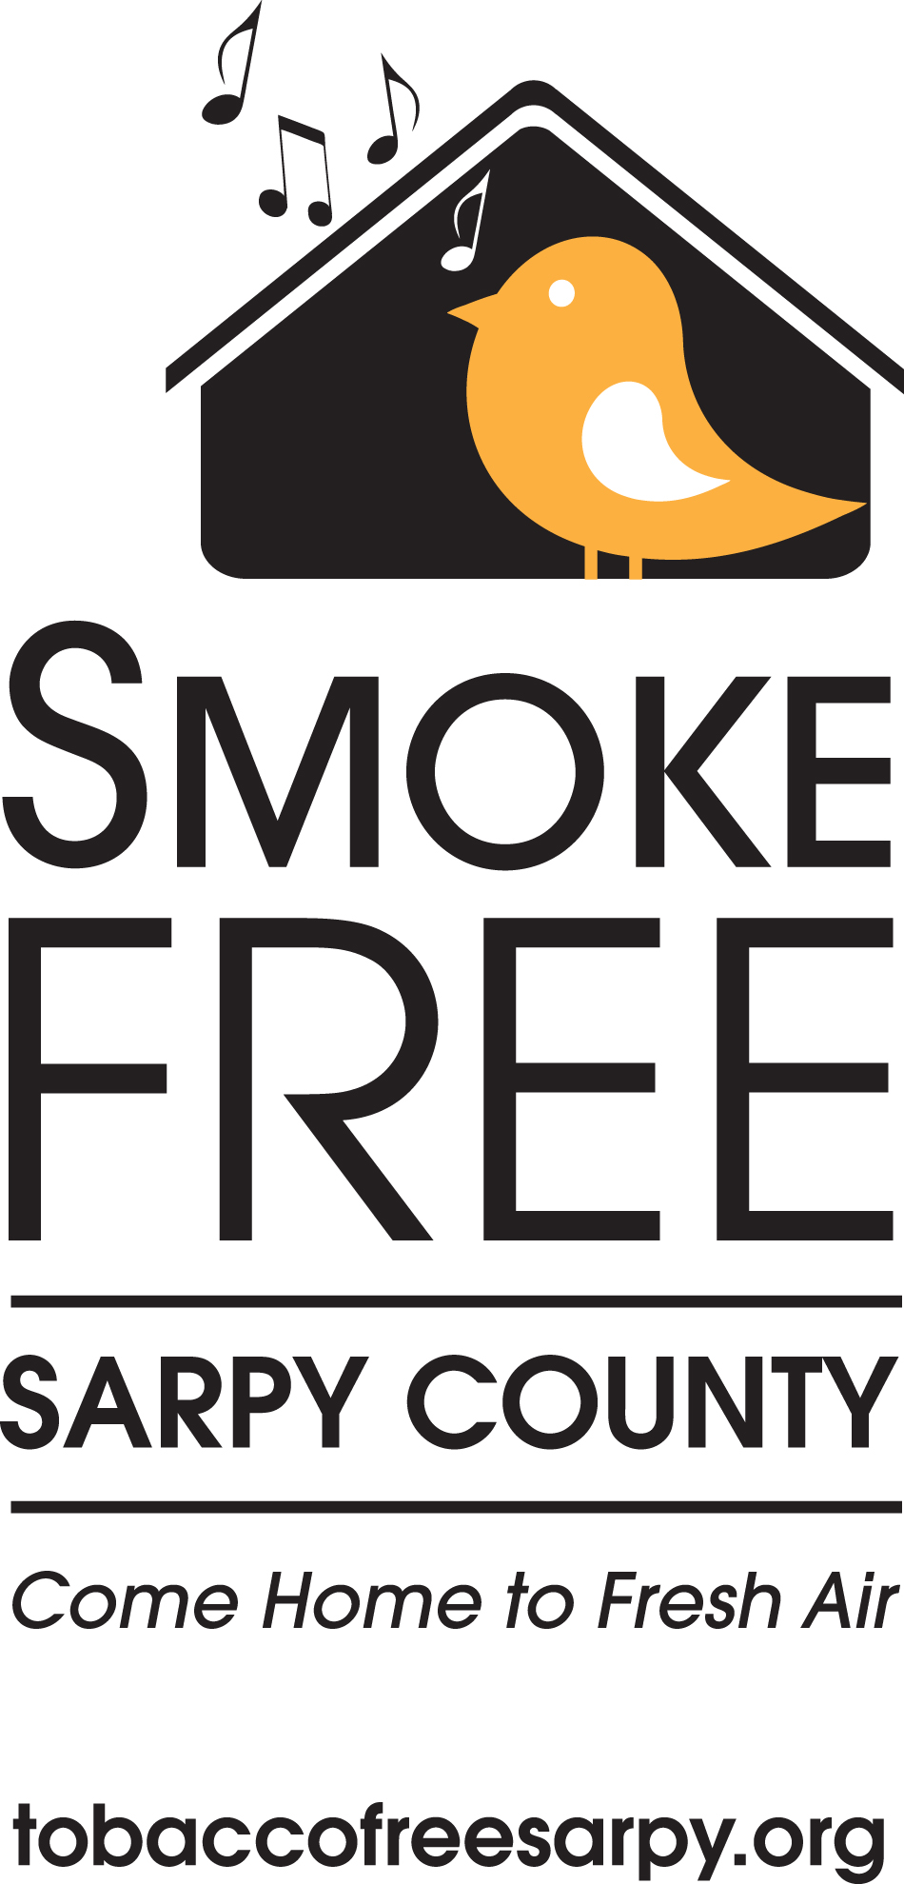
Property Manager and Landlord Luncheon
May 20, 2010
noon – 1:30 p.m.

Program of Events
Registration/lunch noon
Welcome 12:15 p.m. Joan Friedman, Tobacco Free Sarpy
Keynote speaker 12:30 p.m. Jeff Soukup, Tobacco Free Nebraska
Up in Smoke: The Impact of Secondhand Smoke on Your Bottom Line
Toolkit presentation 1:00 p.m. Mary Crosby, PRIDE Omaha
Conclusions 1:20 p.m. Joan Friedman, Tobacco Free Sarpy


